

DEPARTMENT OF COMPUTER SCIENCE AND
ENGINEERING

CS23432 – Software Construction

(REGULATION 2023)

RAJALAKSHMI ENGINEERING COLLEGE
Thandalam, Chennai-602015

Name : HARIHARAN A
Register No : 240701165
Year / Branch / Section : 2ND-YEAR / CSE Semester : 4TH SEMESTER
Academic Year : 2024-2028

INDEX
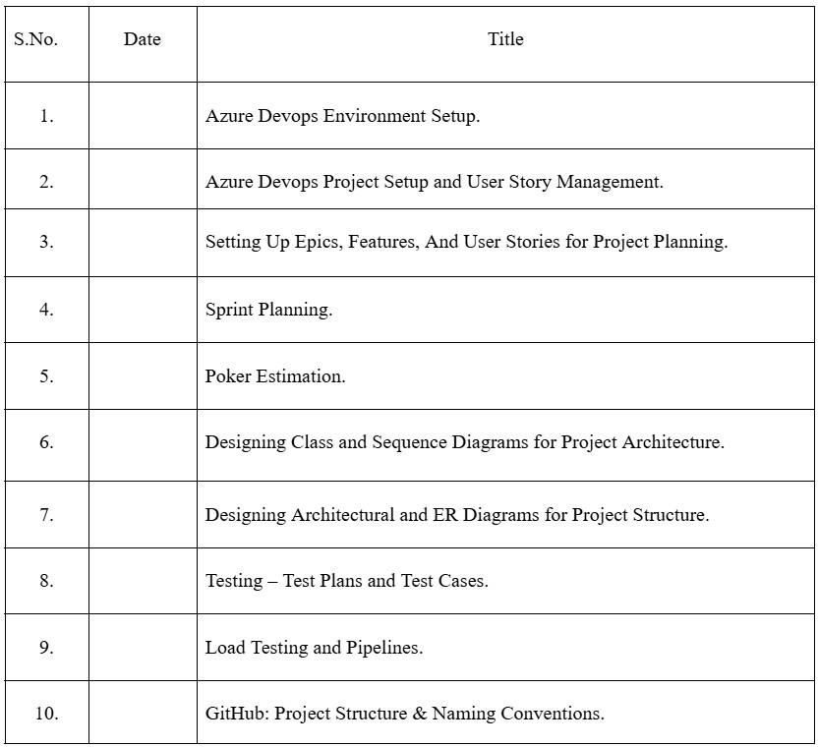

AZURE DEVOPS ENVIRONMENT SETUP

EXP NO :1

Aim:
To set up and access the Azure DevOps environment by
creating an organization through the Azure portal.

INSTALLATION
- Open your web browser and go to the Azure website: https://azure.microsoft.com/en-us/get-started/azure-portal.
Sign in using your Microsoft account credentials. If you don't have a Microsoft account, you can create one here: https://signup.live.com/?lic=1


- Azure home page

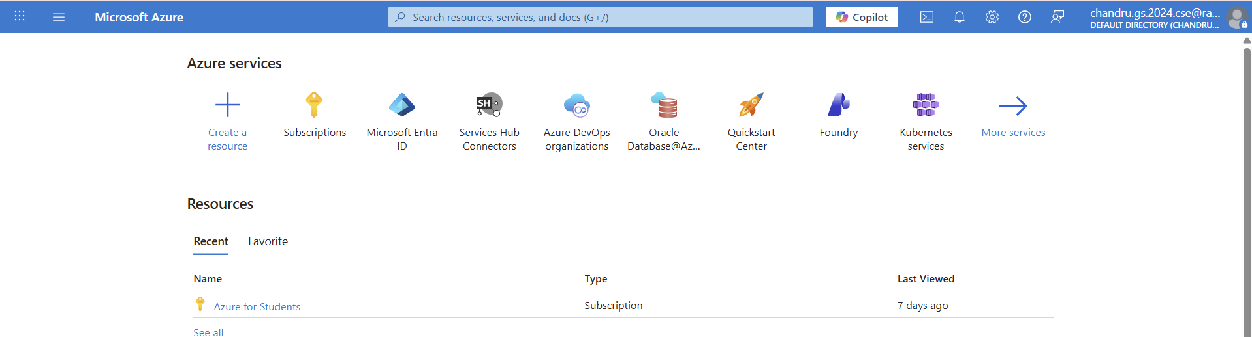

- Open DevOps environment in the Azure platform by typing Azure DevOps Organizations
in the search bar.



- Click on the My Azure DevOps Organization link and create an organization and you should be taken to the Azure DevOps Organization Home page.

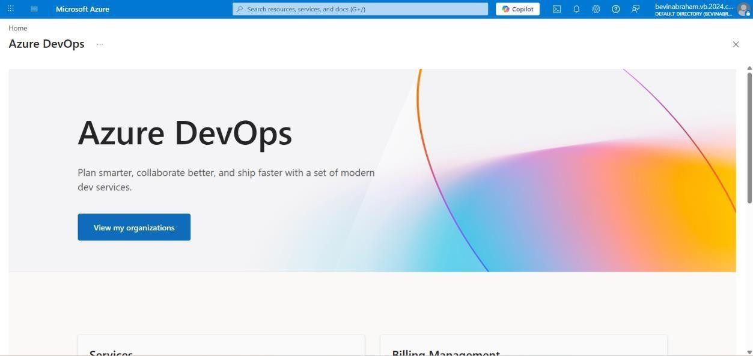

Result:
Successfully accessed the Azure DevOps environment and created a new organization through the Azure portal.

AZURE DEVOPS PROJECT SETUP AND
USER STORY MANAGEMENT

EXP NO : 2
Aim

To set up an Azure DevOps project for efficient collaboration and agile work management.
- Create An Azure Account
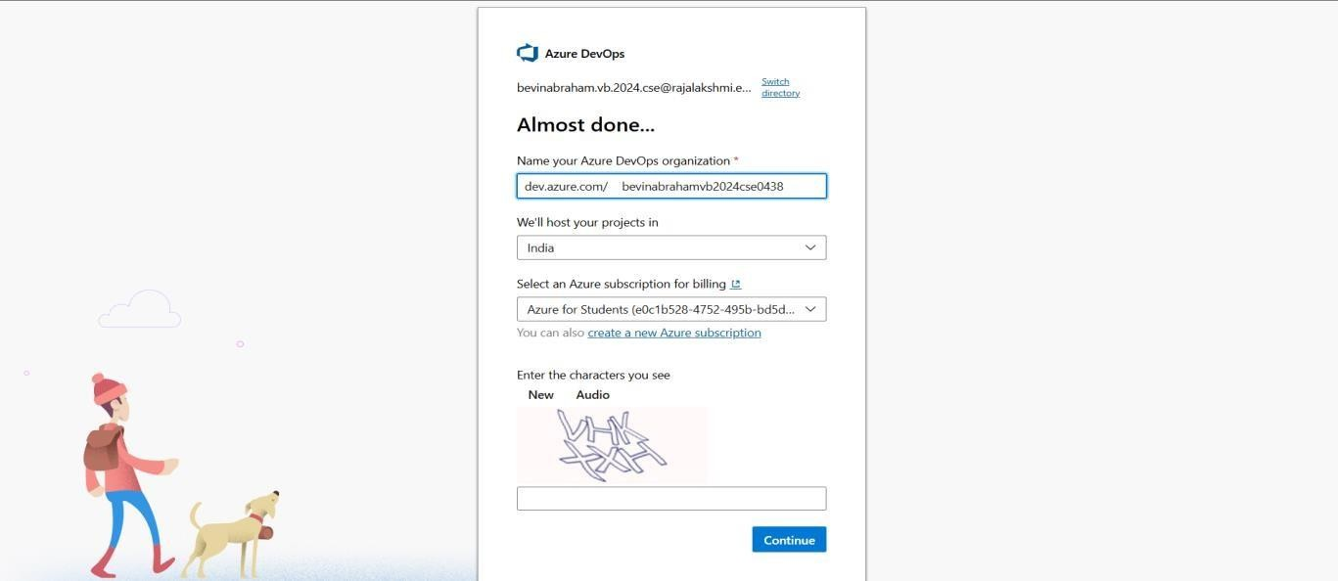
- Create the First Project in Your Organization
  - After the organization is set up, you’ll need to create your first project. This is where you'll begin to manage code, pipelines, work items, and more.
  - On the organization’s Home page, click on the New Project button.
  - Enter the project name, description, and visibility options:
Name: Choose a name for the project (e.g., LMS).
Description: Optionally, add a description to provide more context about the project.
Visibility: Choose whether you want the project to be Private (accessible only to those invited) or Public (accessible to anyone).
  - Once you’ve filled out the details, click Create to set up your first project.

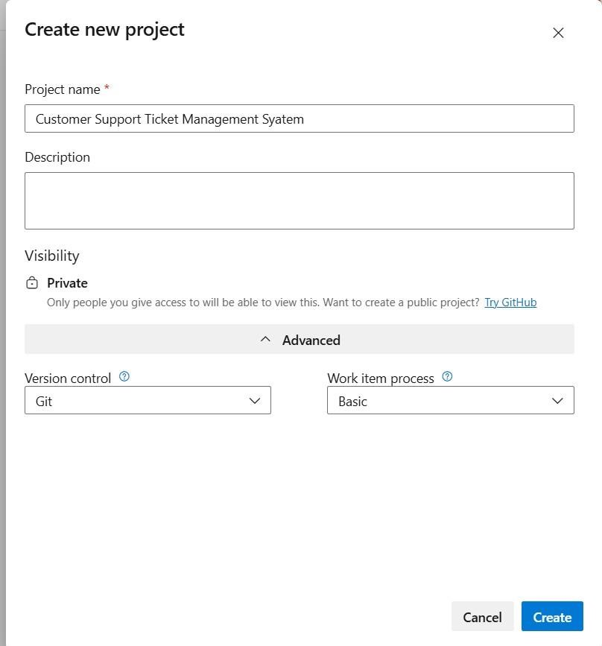

- Once logged in, ensure you are in the correct organization. If you're part of multiple organizations, you can switch between them from the top left corner (next to your user profile). Click on the Organization name, and you should be taken to the Azure DevOps Organization Home page.

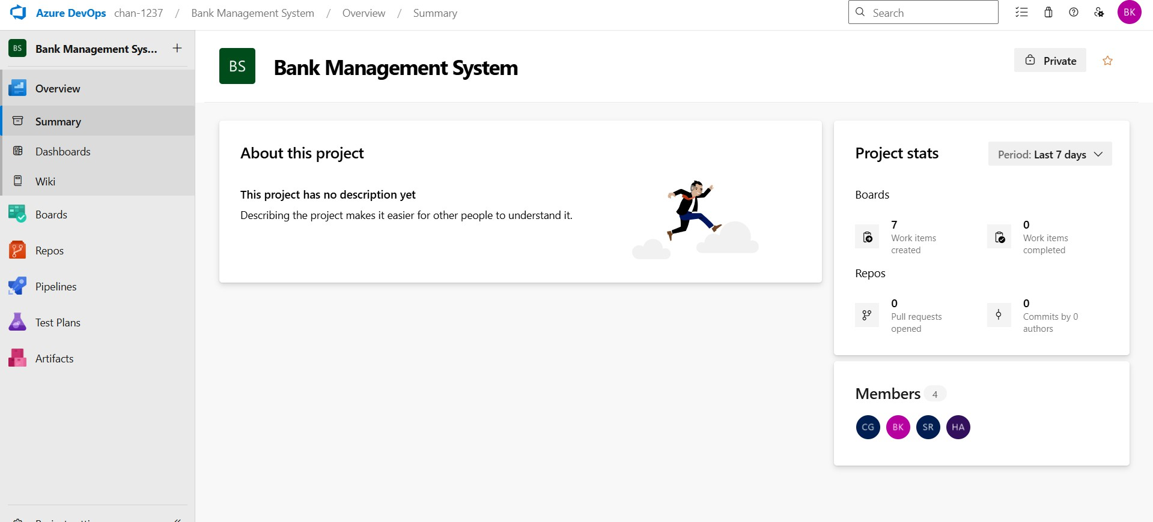

- Project dashboard

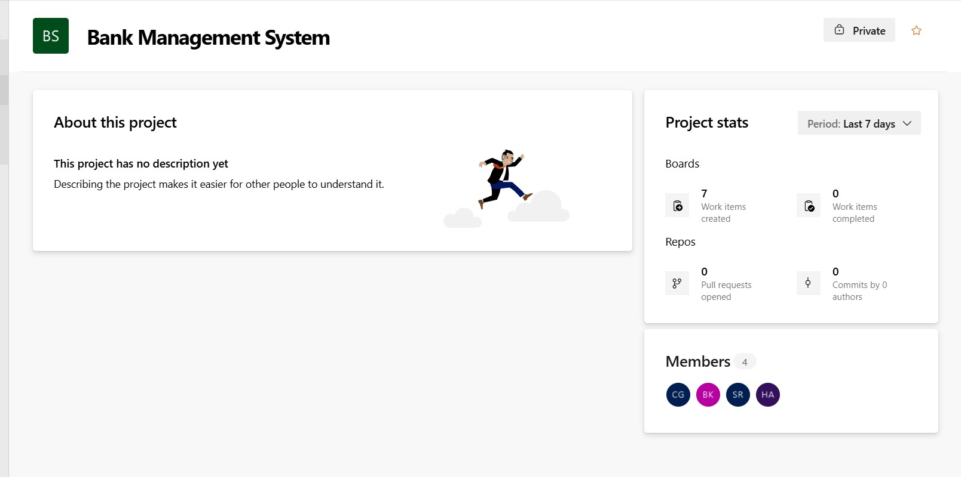

To manage user stories:

  - From the left-hand navigation menu, click on Boards. This will take you to the main Boards page, where you can manage work items, backlogs, and sprints.
  - On the work items page, you'll see the option to Add a work item at the top. Alternatively, you can find a + button or Add New Work Item depending on the view you're in. From the Add a work item dropdown, select User Story. This will open a form to enter details for the new User Story.

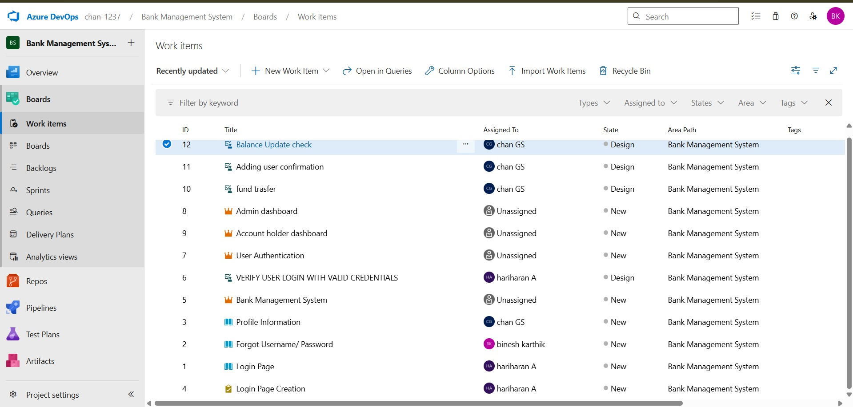

Result:
Successfully created an Azure DevOps
project with user story management and agile workflow setup.

EXP NO : 3 E | SETTING UP EPICS , FEATURES AND USER STORIES FOR PROJECT PLANNING

Aim:

To learn about how to create epics, user story, features, backlogs for
.
your assigned project

Create 1.Epic 2.Features

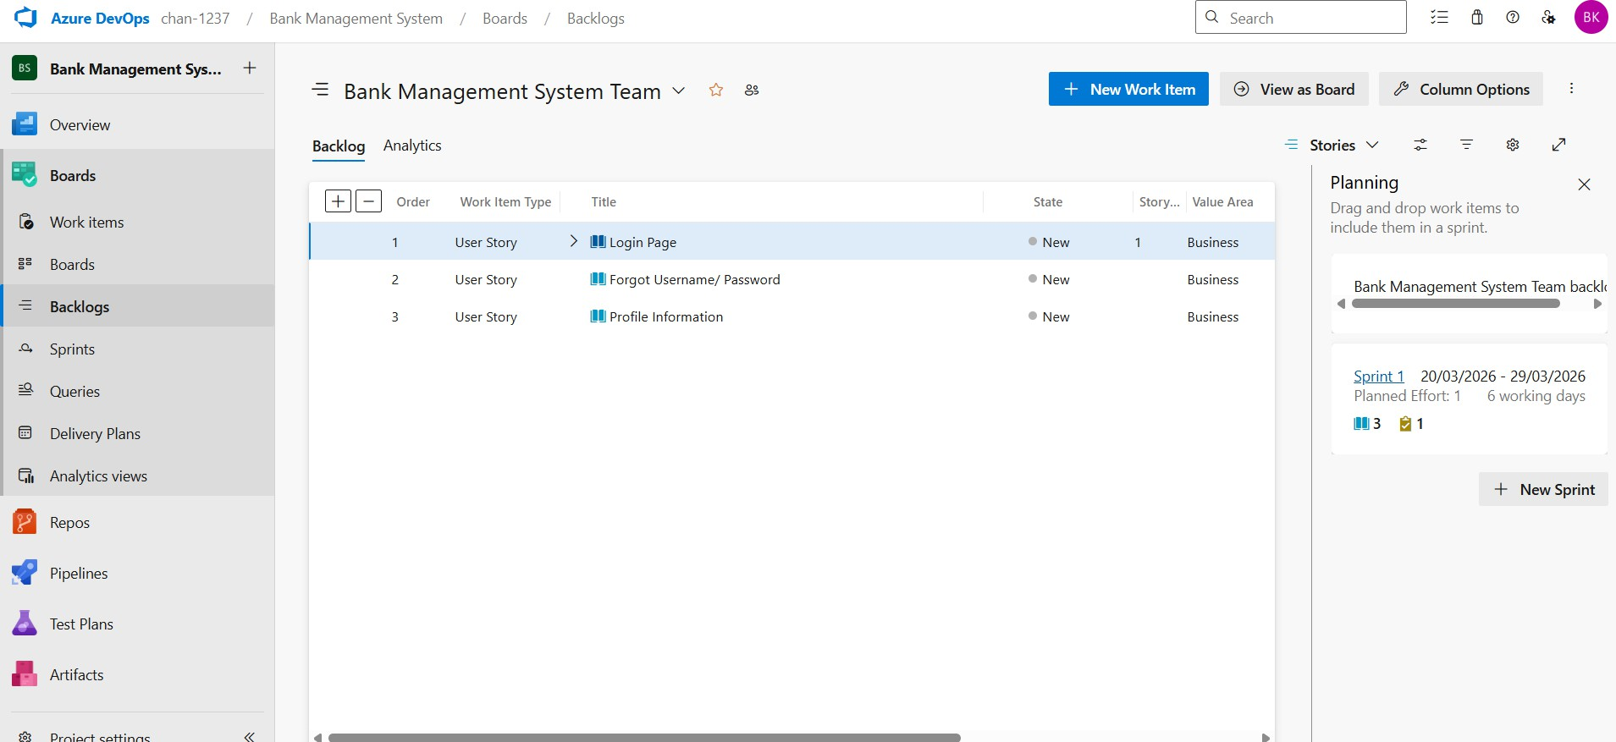
3.User Stories 4.Task

- Fill in Epics

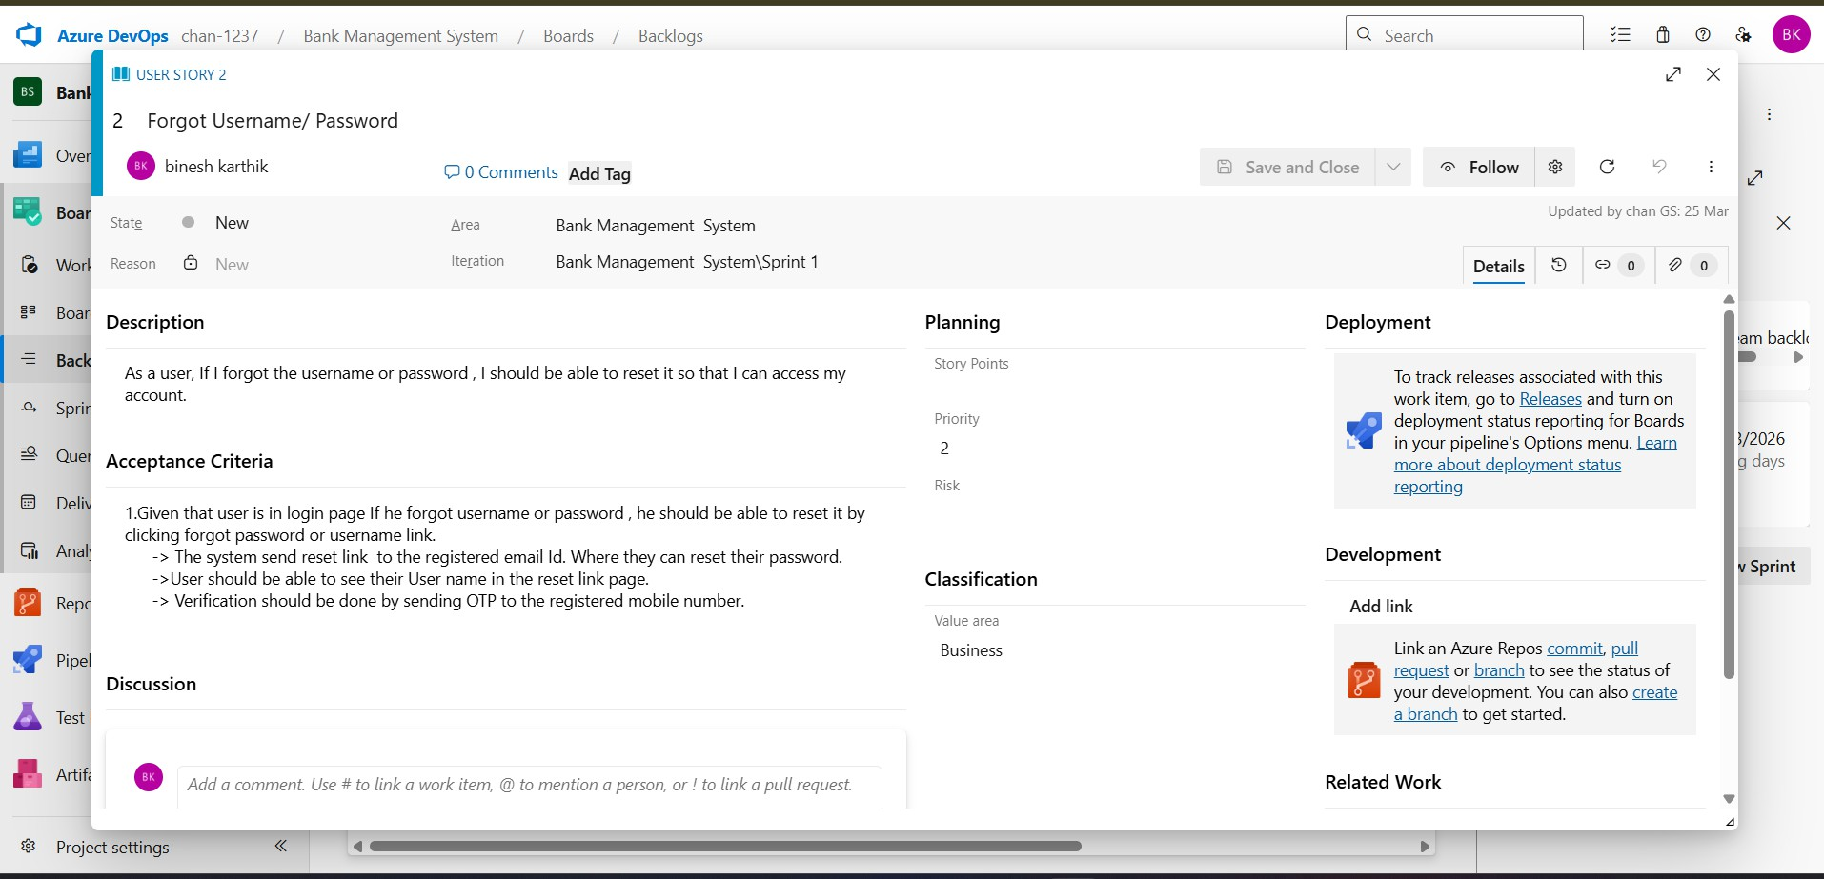

- Fill in Features

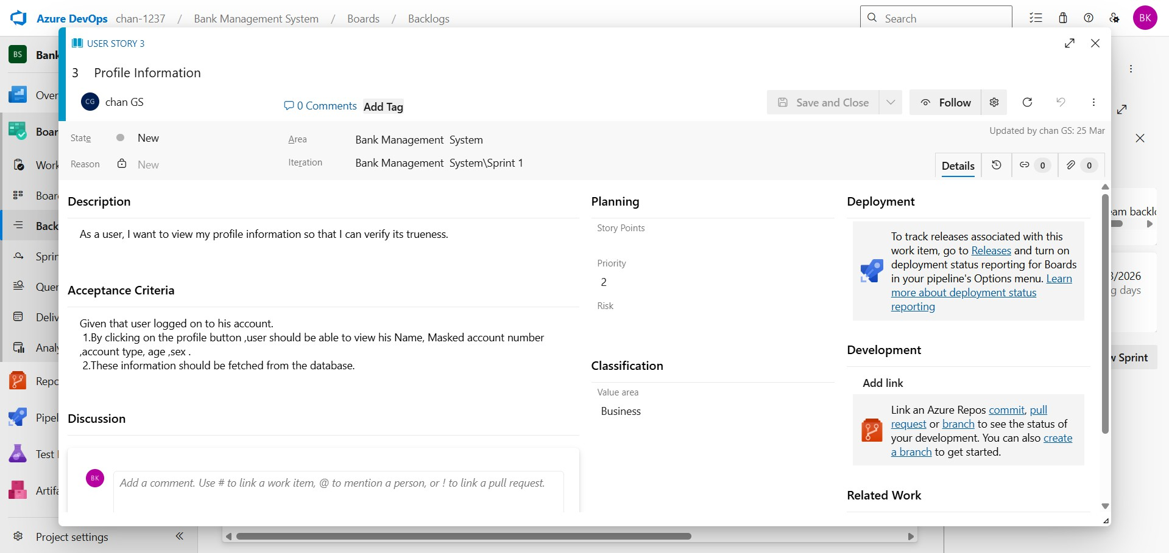

- Fill in User Story Details



Result:
Thus, the creation of epics, features, user story and task has been created successfully for Customer Support Ticket Management System.

SPRINT PLANNING NO : 3
DDDD
EXP
:
NO

EXP 4

Aim:
To assign user story to specific sprint for the Music Playlist Batch Creator Project.

Sprint Planning Sprint 1
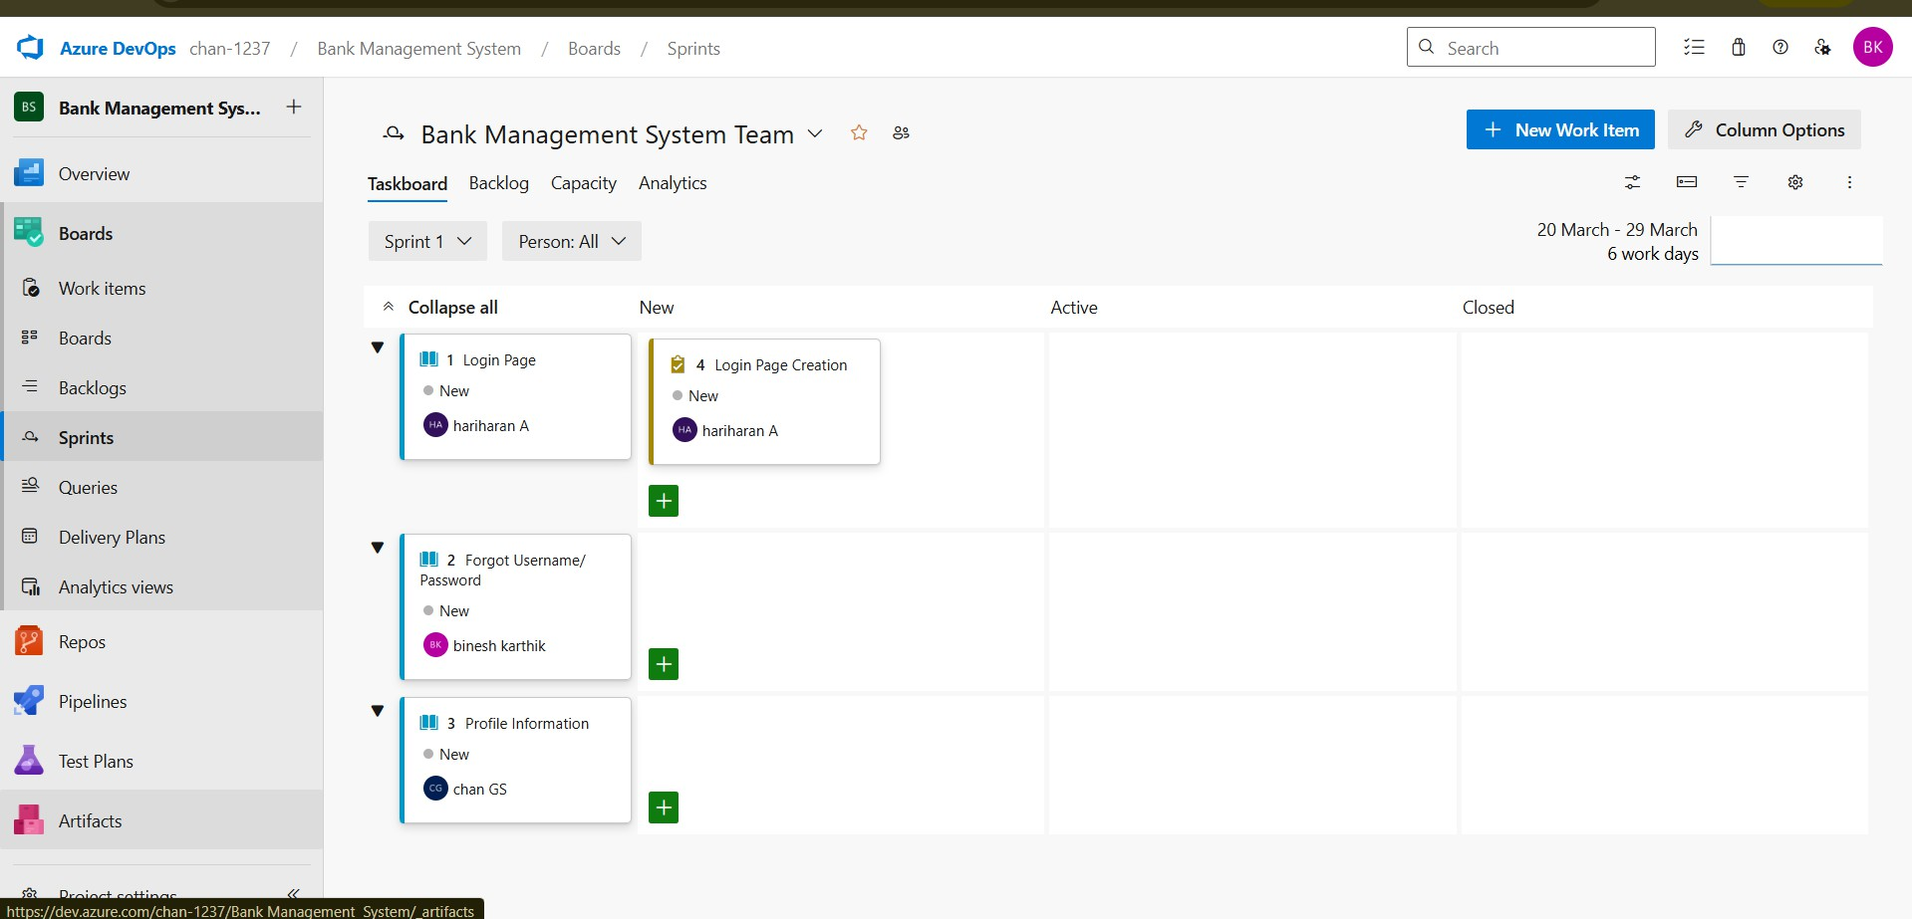

Sprint 2

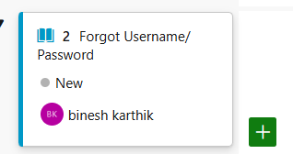

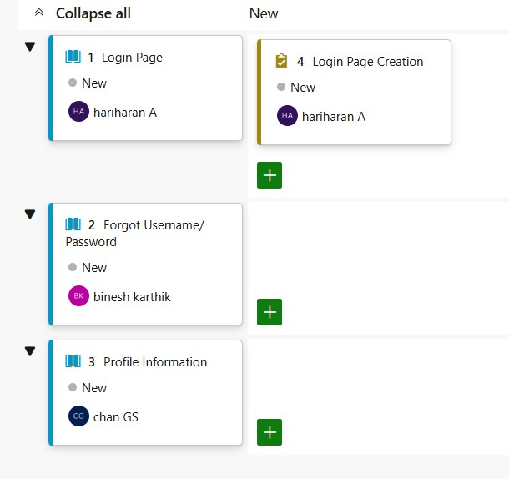
Sprint 3

Sprint 4

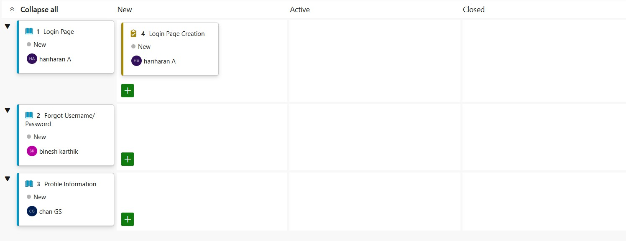

Sprint 5



Result:
The Sprints are created for the Customer Support Ticket Management System

POKER ESTIMATION

EXP NO : 5

Aim:
Create Poker Estimation for the user stories - Music Playlist Batch Creator Project.

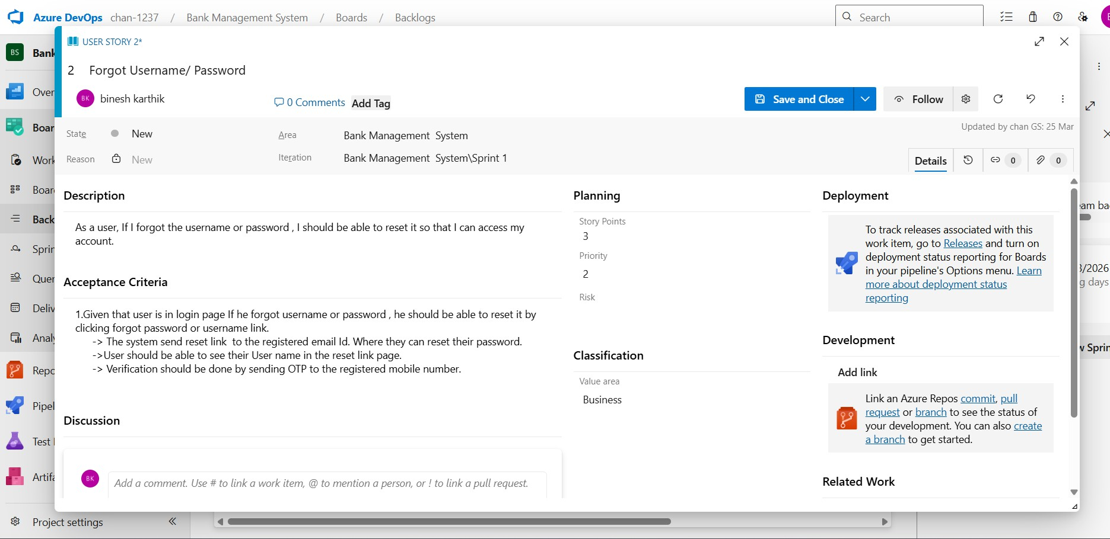
Poker Estimation

Result:

The Estimation/Story Points is created for the project using Poker Estimation.

PROJECT ARCHITECURE
SEQUENCE DIAGRAMS FOR
DESIGNING CLASS AND

EXP NO : 6

Aim:
To Design a Class Diagram and Sequence Diagram for the given Project.

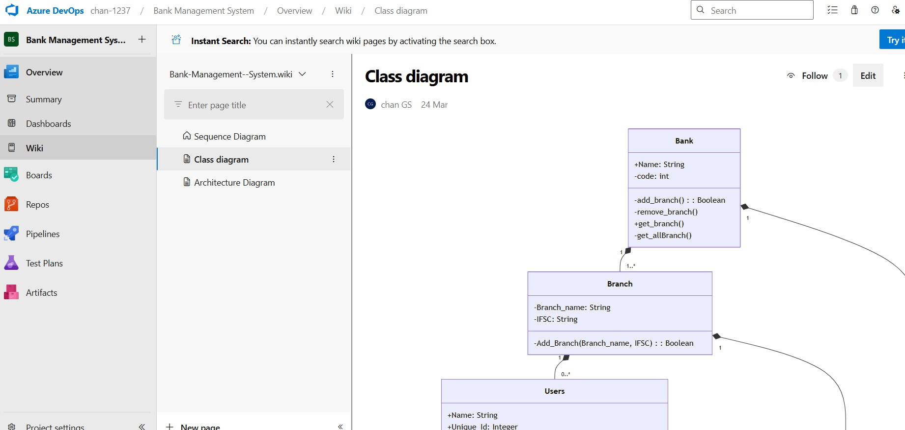
6A. Class Diagram

6B. Sequence Diagram
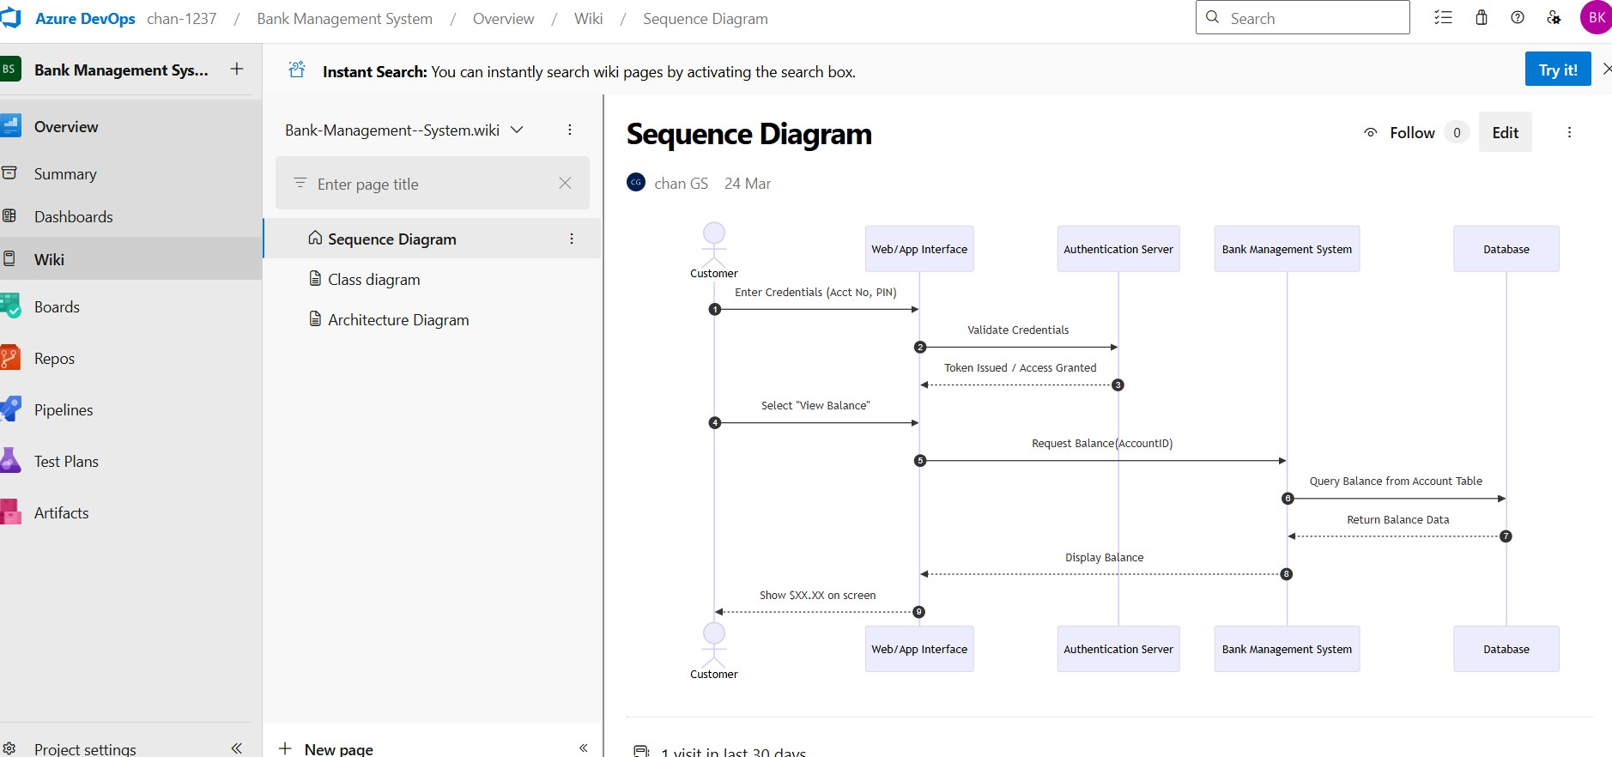

Result:
The Class Diagram and Sequence Diagram is designed Successfully for the Customer Support Ticket Management
System

EXP NO : 7 | DESIGNING ARCHITECTURAL AND ER DIAGRAMS FOR  PROJECT STRUCTURE

Aim:
To Design an Architectural Diagram and ER Diagram for the given Project.

7A. Architectural Diagram

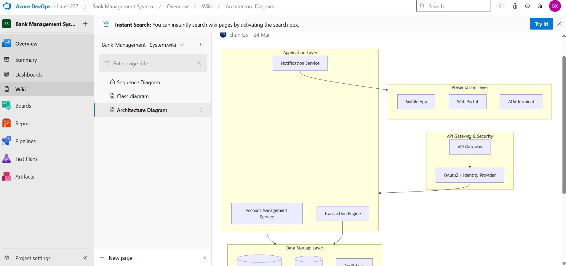

7B.ER Diagram
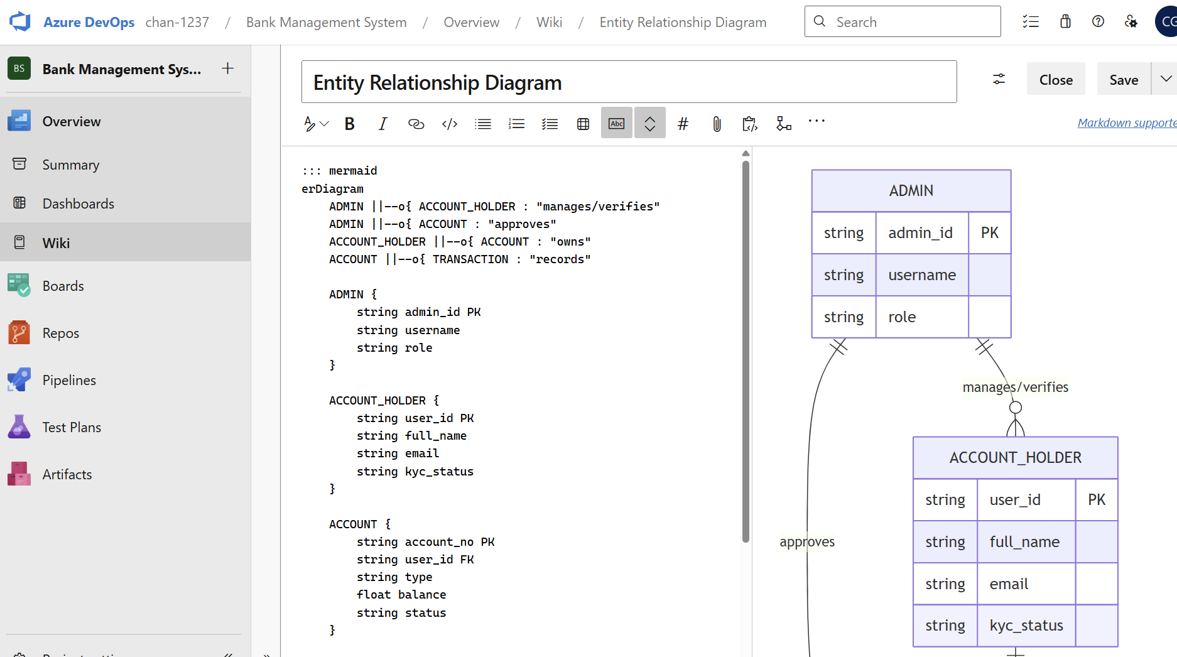

Result:
The Architecture Diagram and ER Diagram is designed Successfully for the CUATOMER SUPPORT TICKET MANAGEMENT SYSTEM.

EXP NO : 8 | TESTING  TEST PLANS AND TEST CASES

Aim:

Test Plans and Test Case and write two test cases for at least five user stories showcasing the happy path and error scenarios in azure DevOps platform.

Test Planning and Test Case Test Case Design Procedure 1. Understand Core Features of the Application 1. Understand Core Features of the Application
The Customer Support Ticket Management System includes the following core functionalities:
- User Signup & Login
- Creating Support Tickets
- Viewing and Tracking Ticket Status
- Assigning Tickets to Support Agents

- Managing Users (Admin Controls)

Define User Interactions
Each test case represents real user actions performed in the system, such as:
  - Logging into the system
  - Creating a support ticket
  - Assigning tickets to agents
  - Viewing ticket status
  - Responding to customer queries
This ensures that the system is tested from an end-user perspective.

Design Happy Path Test Cases
  - Focused on validating that all features function as expected under normal conditions.
Examples:
  - User successfully logs in with valid credentials
  - Customer creates a ticket successfully

Design Error Path Test Cases
  - Simulate negative or unexpected scenarios to test robustness and error handling.
Examples:
  - Login fails with incorrect credentials
  - Ticket creation fails when required fields are empty

Break Down Steps and Expected Results
Each test case is divided into:
  - Step-by-step actions performed by the user

  - Expected results for each step
This helps in clearly validating whether the system behaves as expected.

Use Clear Naming and IDs
  - Test cases are named clearly (e.g., TC01 – Successful Login, TC08 – Ticket Assignment Failure).
  - Helps in quick identification and linking to user stories or features.

Separate Test Suites
Test cases are grouped into test suites based on functionality:
  - Login Module
  - Ticket Creation Module
  - Ticket Assignment Module
This helps in structured testing and easier execution in Azure DevOps.

Prioritize and Review
  - Critical user actions are marked high-priority.
  - Reviewed for completeness and traceability against feature requirements.

- New test plan

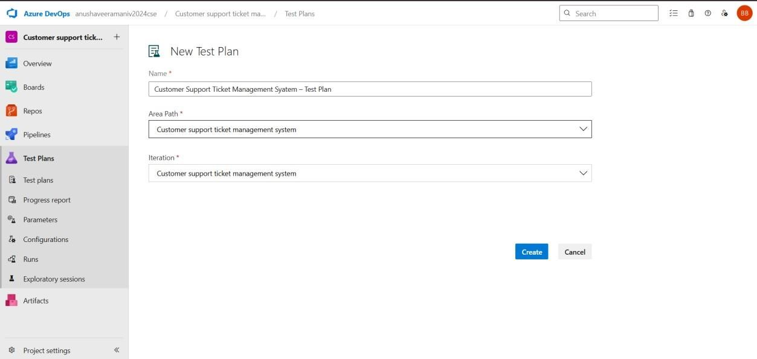

- Test suite

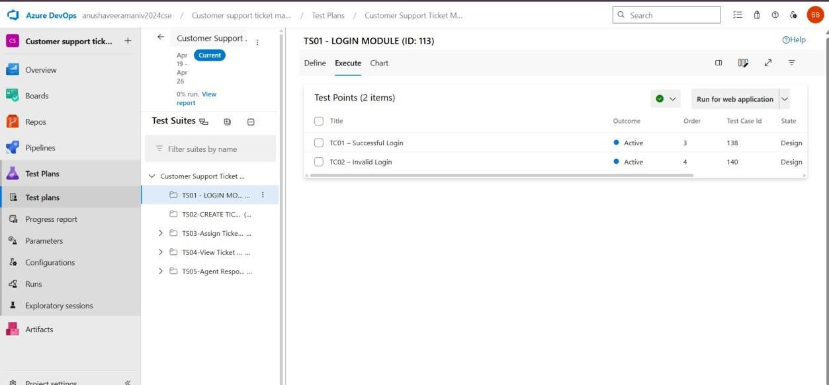

- Test Case
Give two test cases for at least five user stories showcasing the happy path and error scenarios in Azure DevOps platform.
Customer Support Ticket Management System – Test Plans

USER STORIES
  - As a user, I want to sign up and log in securely so that I can access the system.
  - As a customer, I want to create a support ticket with details so that I can report issues.
  - As an admin, I want to assign tickets to specific agents so that issues are handled properly.
  - As a customer, I want to view the status of my ticket so that I can track progress.
  - As a support agent, I want to respond to tickets so that I can resolve user issues.

Test Suites
Test Suit: TS01 – User Login 1. TC01 – Successful Login
  - Action:
    - Enter valid email and password.
    - Click "Login".
  - Expected Results:
    - Login page is displayed. o Fields accept input without error.
    - User is logged in and redirected to dashboard.

Type: Happy Path 2.

TC02 – Invalid Login
  - Action:
    - Go to the Login page. o Enter valid email and wrong password.
    - Click "Login".
  - Expected Results:
    - Input is accepted.
    - Error message "Invalid credentials" is displayed.

Test Suite: TS02 – Account Operations

3. TC03 – View Balance Successfully
- Action:
  - Login as Account Holder.

  - Select the "Account Summary" dashboard.
- Expected Results:
  - Current balance is displayed correctly ($XX.XX).
  - Account status is shown as "Active."
- Type: Happy Path

4. TC04 – Withdrawal with Valid Amount
- Action:
  - Navigate to "Withdrawal" section.
  - Enter an amount less than the current balance.
  - Click "Confirm."
- Expected Results:
  - Cash/Success message is displayed.
  - Balance is updated immediately in the Database.
- Type: Happy Path

5. TC05 – Withdrawal with Insufficient Funds
- Action:
  - Navigate to "Withdrawal" section.
  - Enter an amount greater than the current balance.
  - Click "Confirm."
- Expected Results:
  - Error message "Insufficient Funds" is displayed.
  - Transaction is denied and balance remains unchanged.
- Type: Error PatTest Suite: TS03 – Admin Oversight

6. TC06 – Admin Approve New Account
- Action:
  - Login as Admin.
  - Open "Pending Requests" list.
  - Select a request and click "Approve."
- Expected Results:
  - Account status updates to "Active."
  - Account Holder is now able to login.
- Type: Happy Path

7. TC07 – Admin Search Invalid User ID
- Action:
  - Navigate to "User Management."
  - Enter a non-existent User ID in the search bar.
  - Click "Search."
- Expected Results:
  - Error message "User not found" is displayed.
  - The results table remains empty.
- Type: Error Path

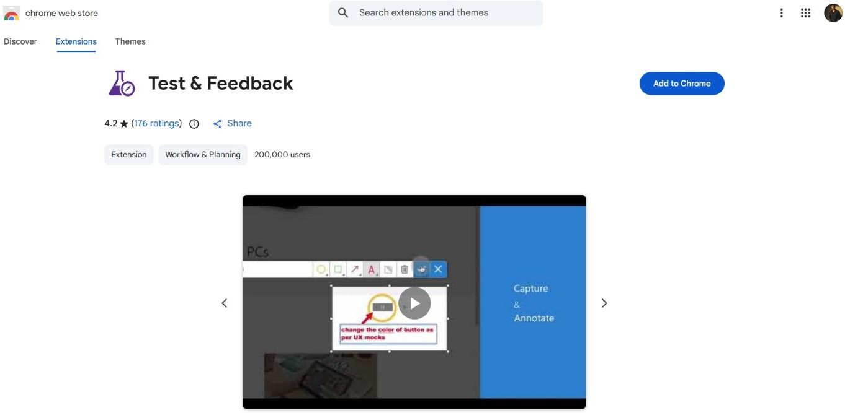
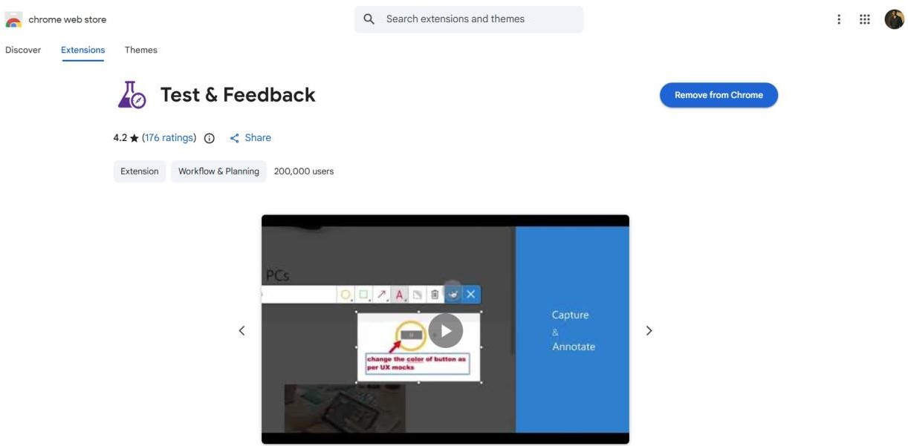
4.Installation of test

Test and feedback Showing it as an extension

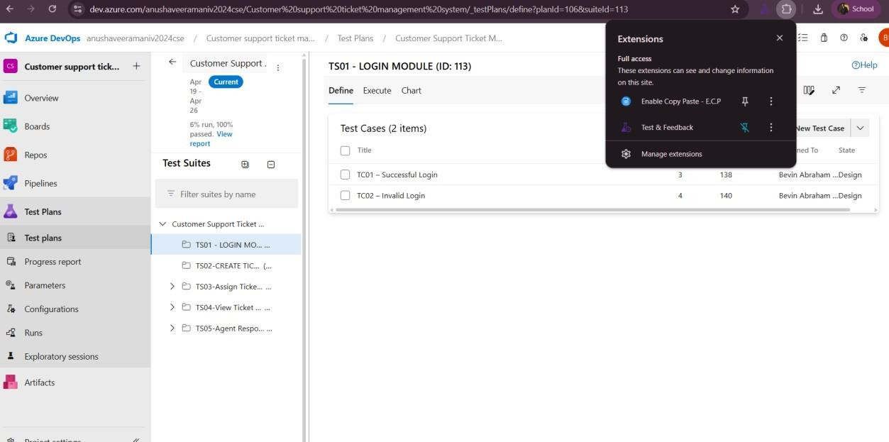
- Running the test cases
Press the 3dots icon to run the Test Case
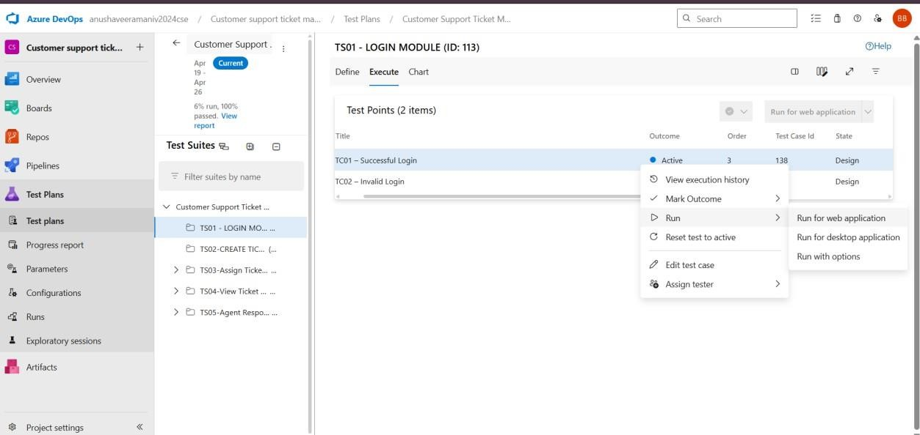

After Running the Test Case

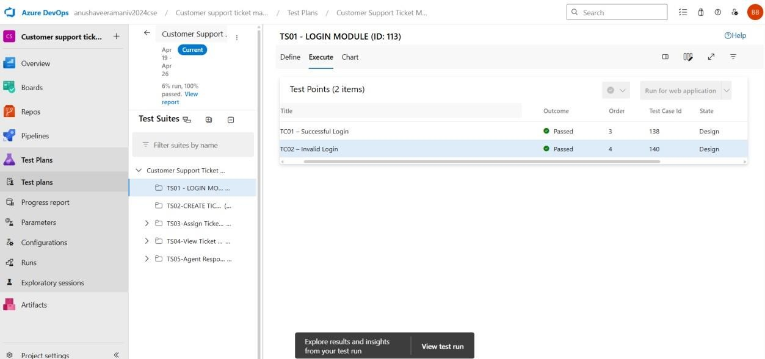
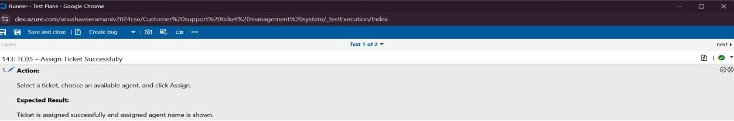

- Recording the test case

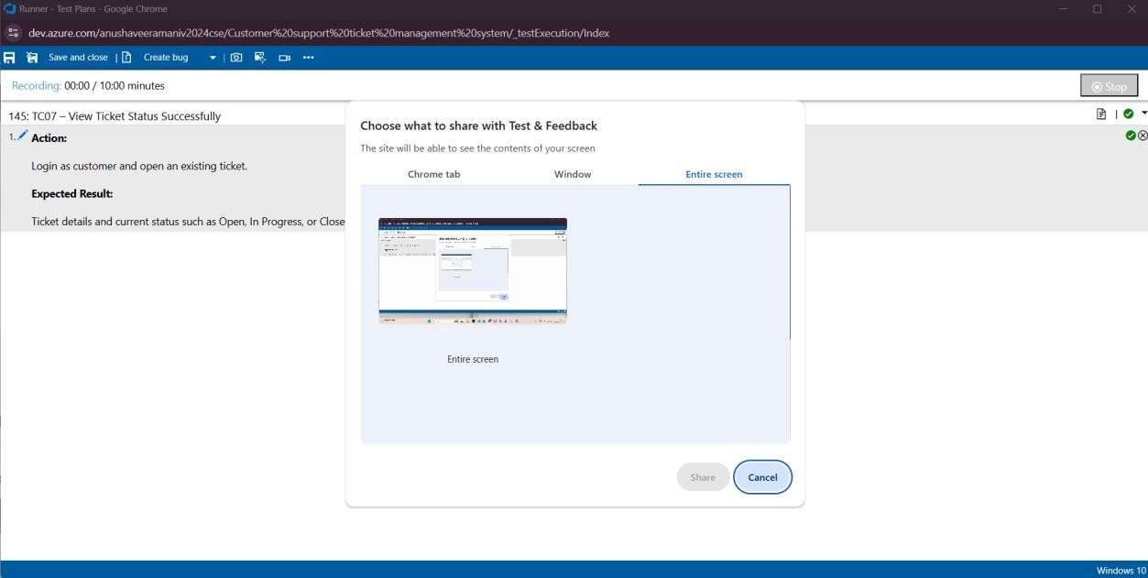

6.Creating the bug

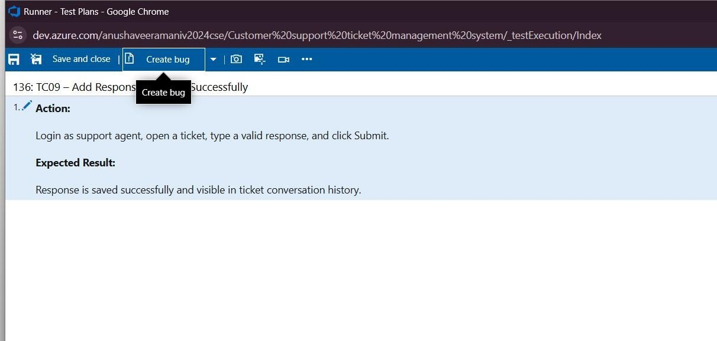

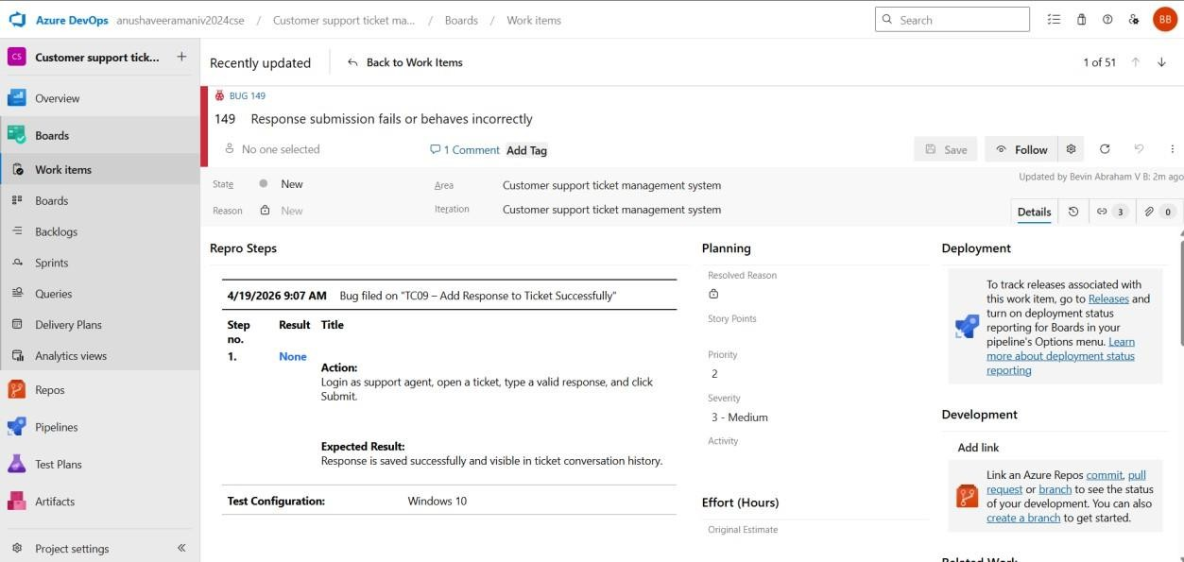

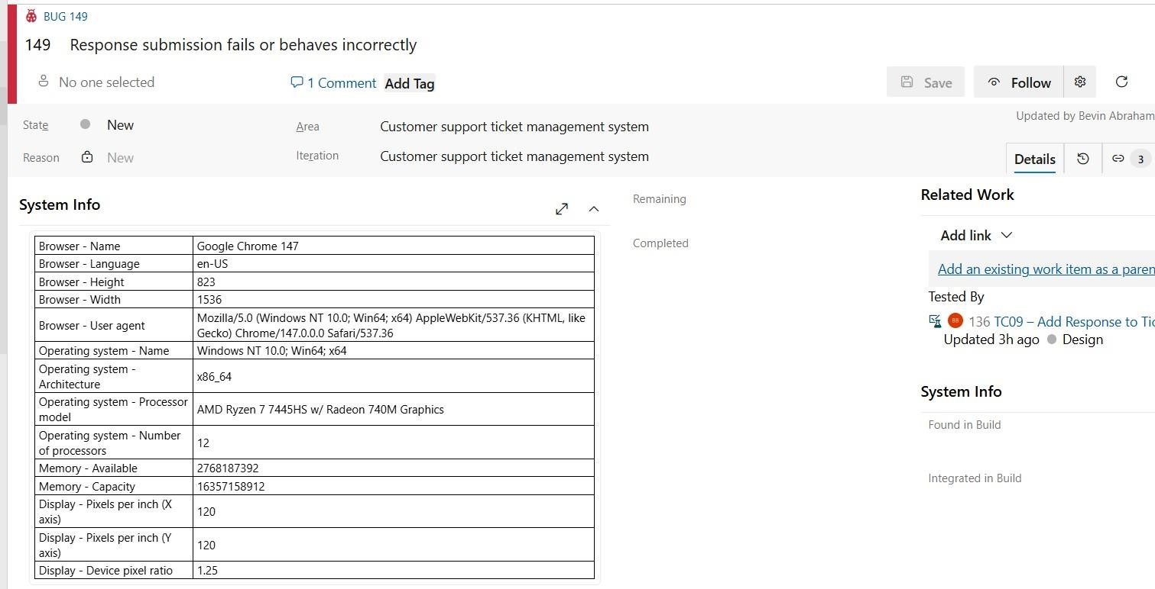

- Test case results

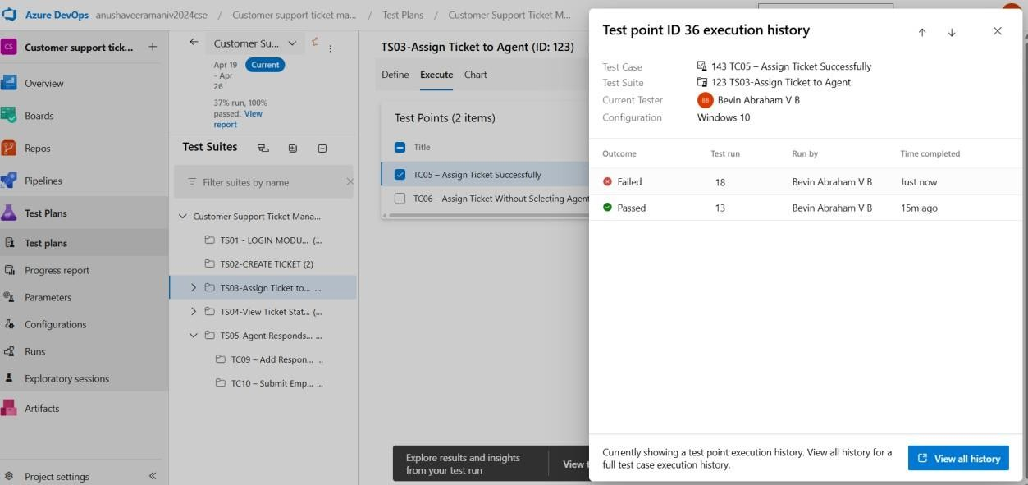

- Test report summary


Assigning bug to the developer and changing state

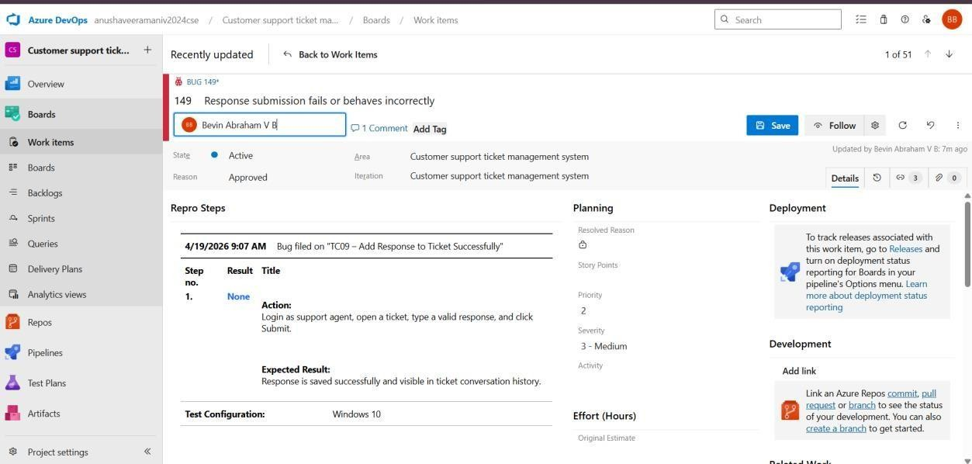

- Progress report

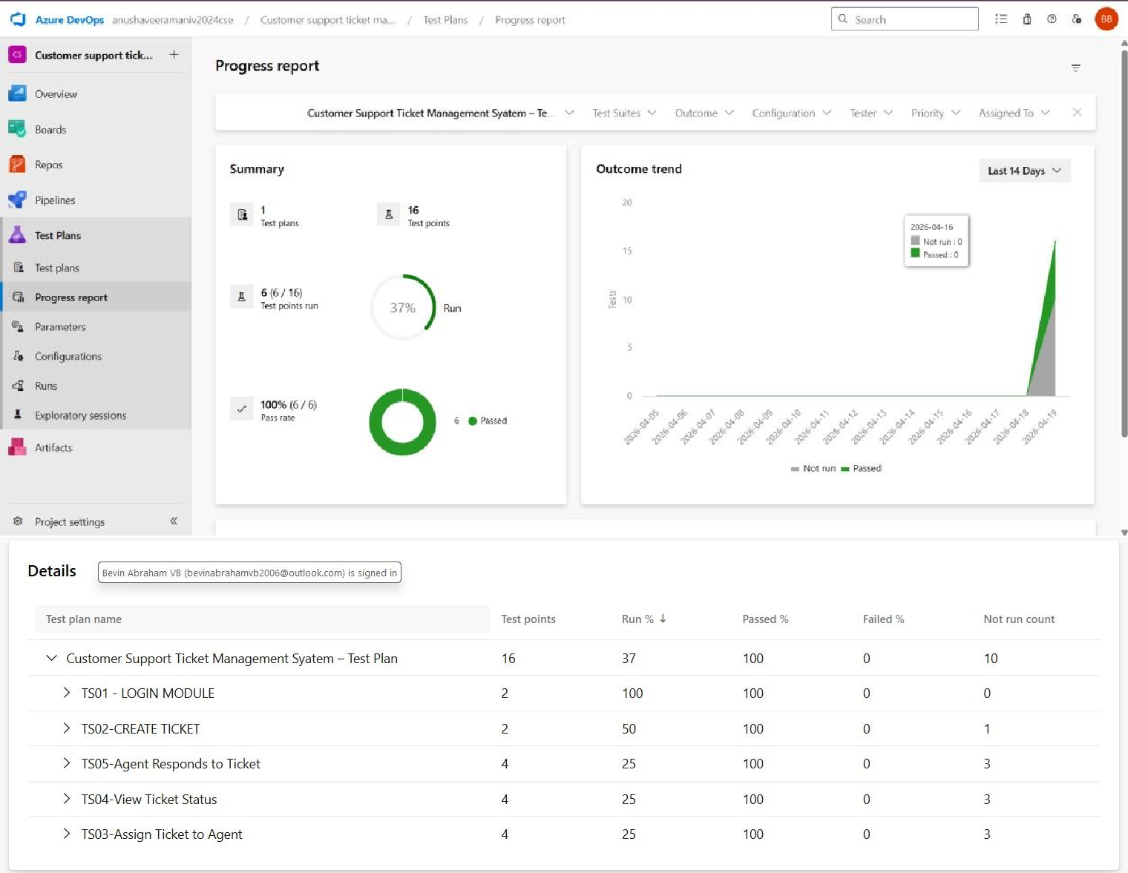

- Changing the test template

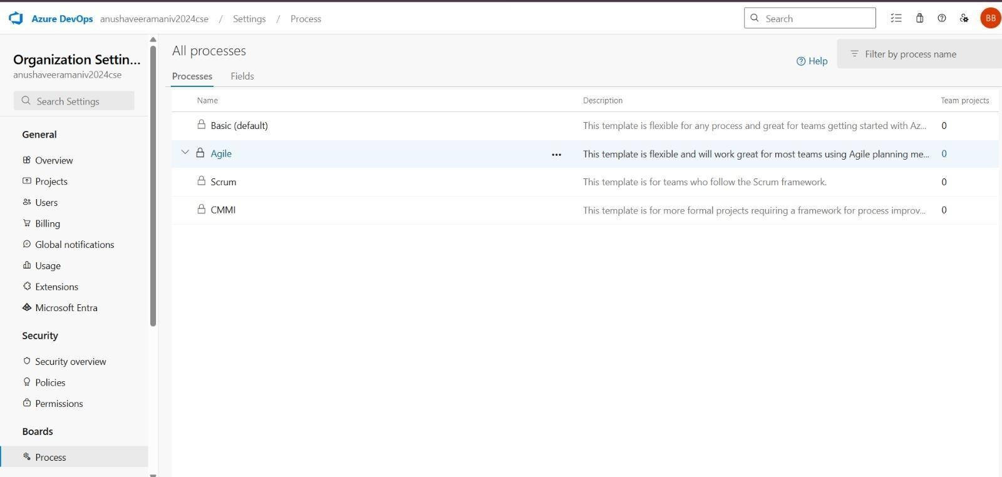

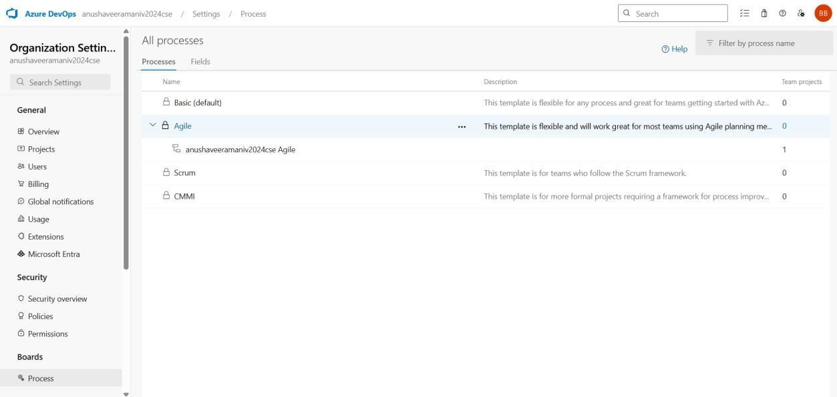

- View the new test case template

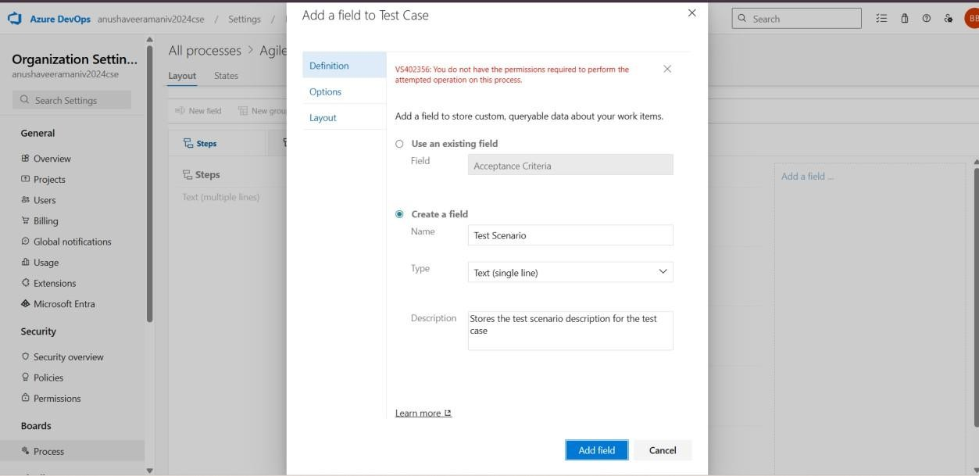

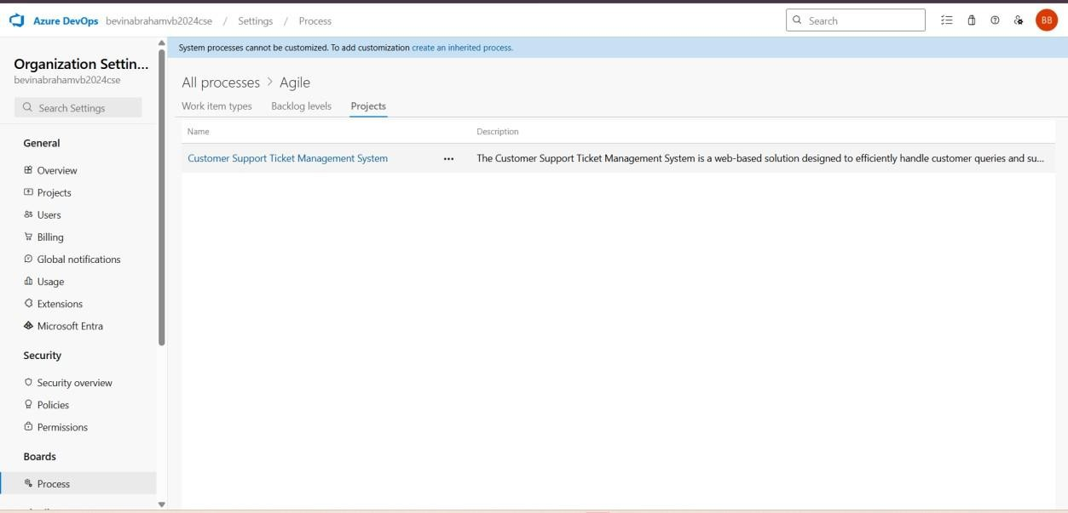

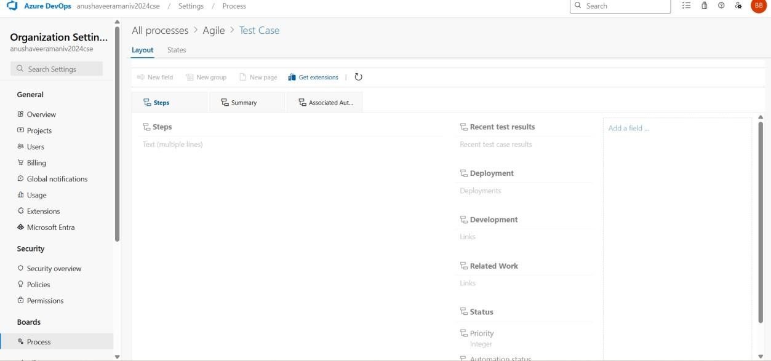

Result:

The test plans and test cases for the user stories is created in Azure DevOps with Happy Path and Error Path

EXP NO : 9 | LOAD TESTING & PIPELINES

Azure Load Test

Aim:
To create an Azure Load Testing resource and run a load test to evaluate the performance of a target endpoint and to create and demonstrate an Azure DevOps pipeline for automating application builds, tests, and deployment.

Load Testing
Azure Load Testing:
Azure Load Testing allows you to simulate high traffic and stress tests for your web applications and APIs to understand how they perform under load. It helps identify performance bottlenecks, scalability issues, and optimize resource usage before deployment.

Steps to Perform Load Testing in Azure Pipeline using k6

1.Create the k6 Test Script Write a JavaScript file (e.g., load-test.js) and save it in your project repository. This

script defines the number of virtual users, the test duration, and the target URL (e.g., your bank system API).

2. Define Performance Thresholds Inside the script, add "Thresholds" to set your pass/fail criteria. For example,

you can set a rule that 95% of requests must respond in less than 500ms. If the test fails these criteria, it will

automatically fail the Azure Pipeline.

3. Configure the Azure Pipeline YAML Open your azure-pipelines.yml file and add a job to handle the testing

process. You will need to use a Linux agent (like ubuntu-latest) to run the commands.

4.Install k6 on the Build Agent Add a command-line script step to your pipeline to download and install k6. Since

build agents start "fresh" each time, you must include the installation commands (using apt-get for Ubuntu) to ensure

the k6 command is available.

5. Execute the Load Test Add a second script step to run the test using the command k6 run load-test.js. If you

want to view the results in the Azure DevOps "Tests" tab, add a flag to export the results into a file format like JUnit or

JSON.

6. Publish and Review Results Add a "Publish Test Results" task to your pipeline. This uploads the data from the k6

run so that you can view a summary of the performance, errors, and response times directly in the Azure DevOps

dashboard after the build completes.

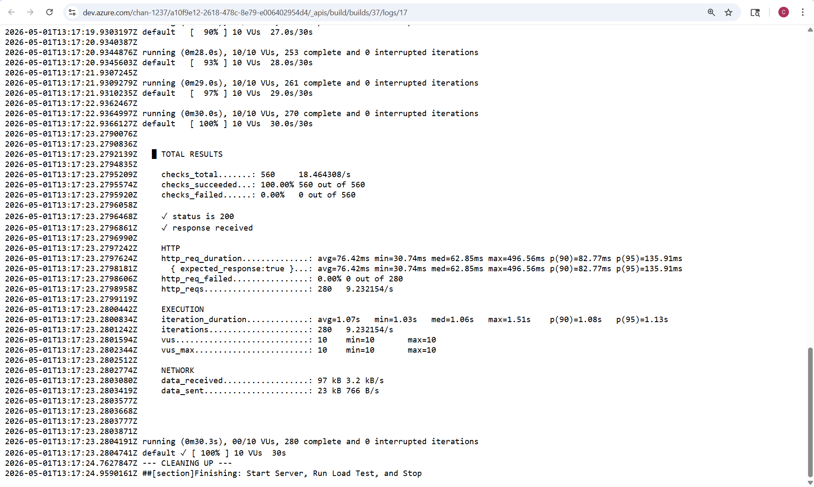
Load Testing Result

Pipelines

Description:
This experiment demonstrates how to create and configure an Azure DevOps pipeline for a Customer Support Ticket Management System. The pipeline is designed to automate the process of installing dependencies, building the frontend, and verifying backend execution. By using continuous integration, every change pushed to the repository triggers the pipeline, ensuring that the application is consistently tested and maintained. This improves code reliability and supports efficient development practices..

Steps:

- Connect Repository to Azure DevOps:
  - Created a new project in Azure DevOps.
  - Uploaded the Customer Support Ticket Management System code into Azure Repos.
  - Ensured that Azure DevOps can access the repository for pipeline execution.

- Create azure-pipelines.yml in the Repository:

  - Created a new file named azure-pipelines.yml in the root directory of the project.
  - Defined the pipeline configuration for a Node.js based application.
  - Configured the pipeline to install dependencies and build the frontend and backend.

YML-Code
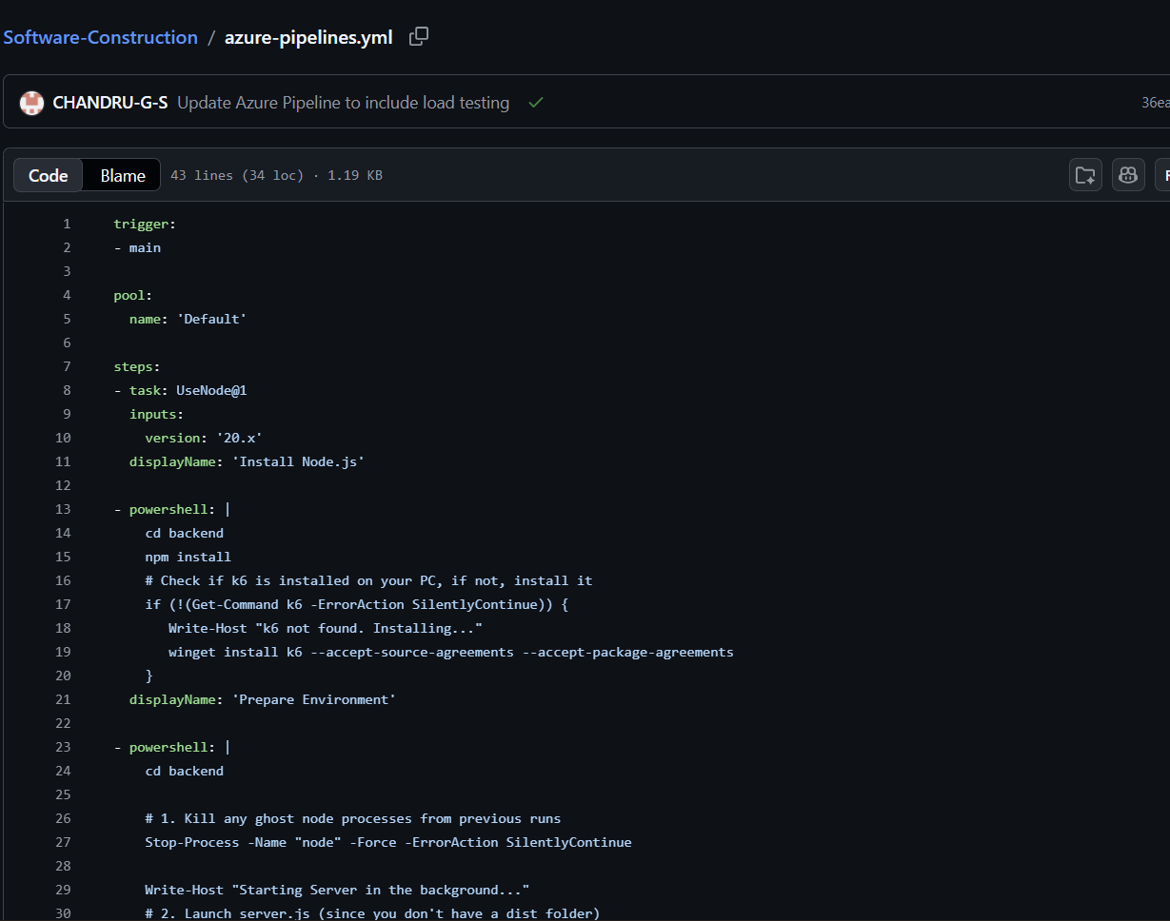
- Pipeline Tasks Include:
  - Installed Node.js environment using NodeTool task.
  - Installed frontend dependencies using npm install.
  - Built the frontend using npm run build.

  - Installed backend dependencies.
  - Executed a simple backend script to verify successful pipeline execution.
- Run and Monitor Pipeline:
  - Saved and executed the pipeline in Azure DevOps.
  - The pipeline was automatically triggered on the main branch.
  - Monitored logs, build steps, and execution status in the Azure DevOps portal.
  - Verified that all stages completed successfully.
Pipeline-Note:
The pipeline was successfully configured and executed. Due to Azure subscription limitations, hosted parallelism was not available. However, the pipeline configuration and execution steps were verified.

Result:
Successfully created the Azure Load Testing resource and executed a load test to assess the performance of the specified endpoint and also demonstrated pipelines in azure devops.

GITHUB
PROJECT STRUCTURE &NAMING CONVENTIONS
Aim:
EXP NO : 10

Aim:

To organize and present the folder structure of the Customer Support Ticket Management System for easy understanding, navigation, and future development.

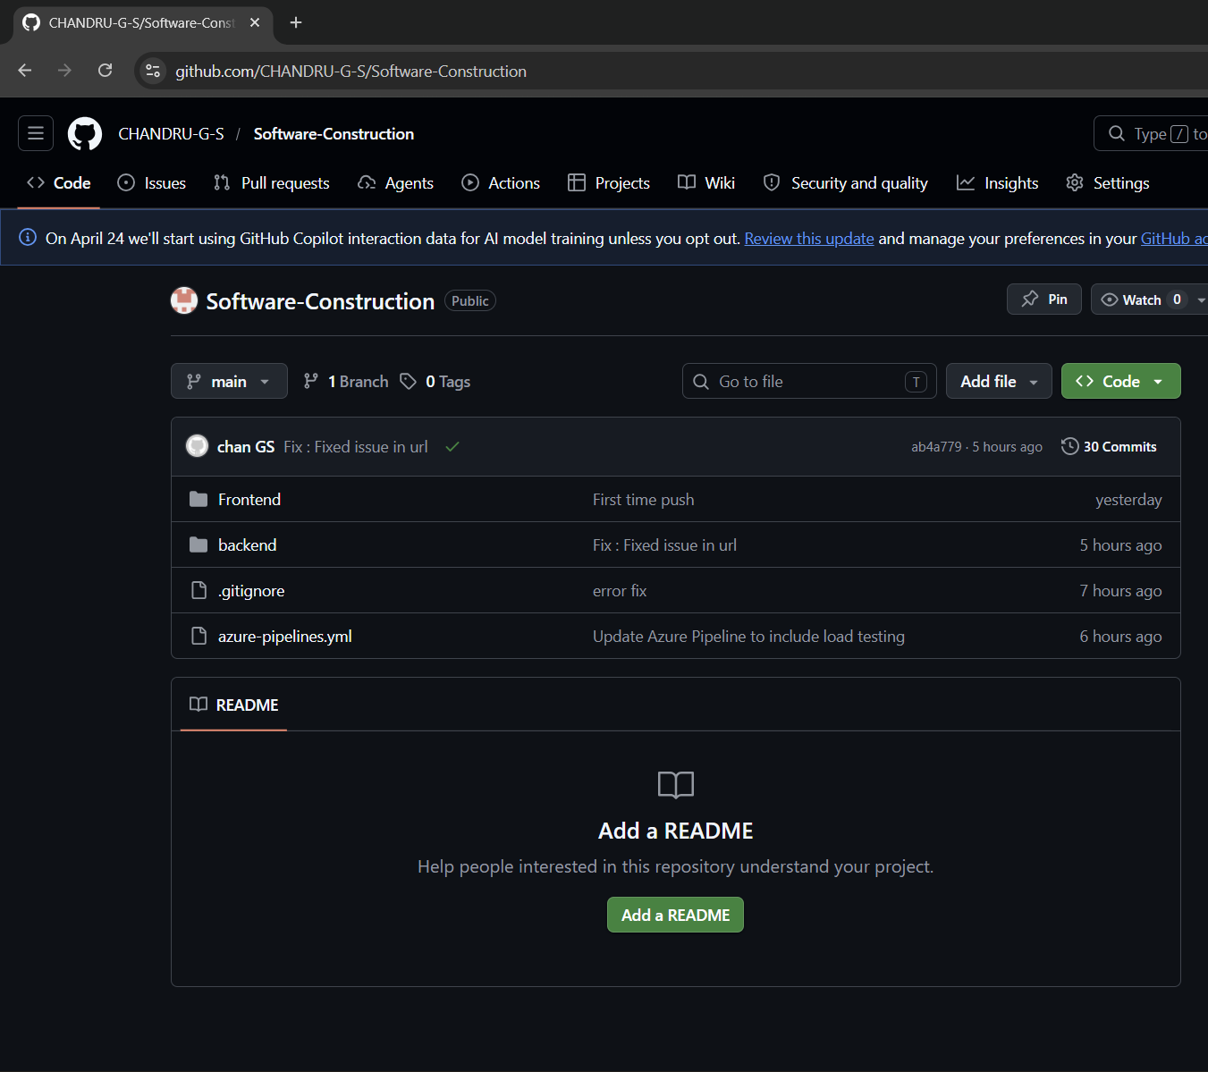
GitHub Project Structure

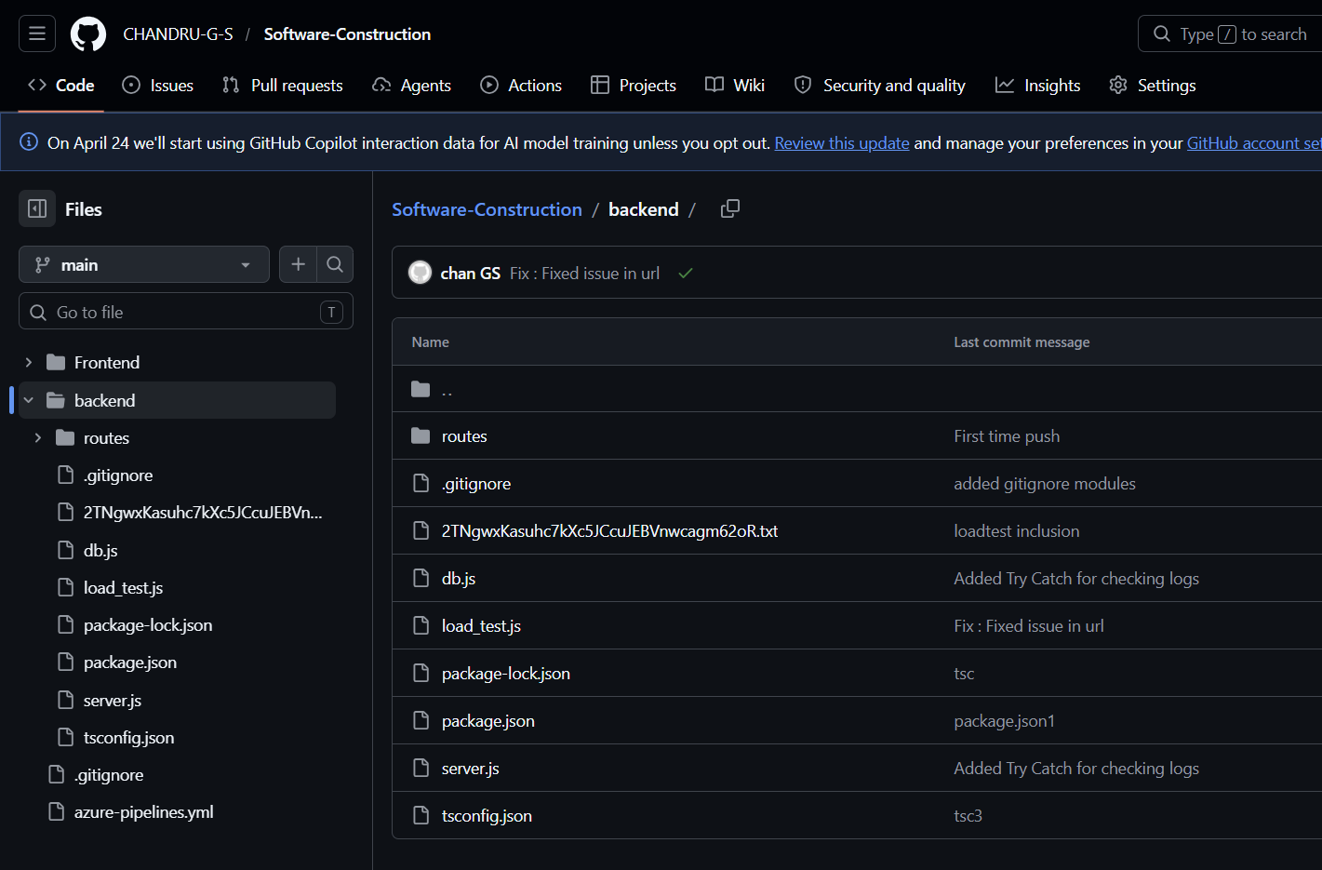

Result:

The GitHub repository clearly displays the organized project structure and consistent naming conventions, making it easy for users and contributors to understand and navigate the codebase.

